
A 12
Set No : 2
Sreenidhi Institute of Science & Technology
(An Autonomous Institution)
Code No: 121MA01

B. TECH. I – Year I – Semester Examinations, February, 2013 (Regular)
ENGINEERING MATHEMATICS – I ( ME, CSE & IT )

Time: 3 Hours Max. Marks : 70

Note : No additional answer sheets will be provided.

Part-A (Objective Type)
Max.Marks:20

Answer all QUESTIONS.

1. If x=r cos θ, y=r sin θ, find 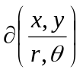.
2. The Eigenvalues of diagonal matrix are ____________.
3. Find the length of the arc of the parabola
y² = 4 ax off by its latus rectum.
4. The value of 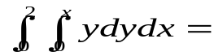___________.
5. Evaluate the line integral 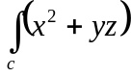 dr, where c : x = t, y=t², z=3t, 1≤t≤2.
6. The series 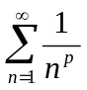converges if p___________ and diverges if p________.
7. Find the rank of 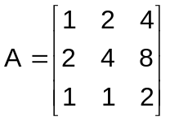.
8. Find the total differential of the function
Z=tan⁻¹ 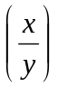, (x,y) ≠ (0,0).
9. Verify whether the vectors (1,0,0) (0,1,0) and (0,0,1) are linearly independent or dependent.

10. Evaluate the double integral
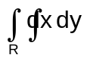,
where R is the region bounded by 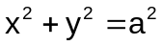in the first quadrant.
Part – B
Max. Marks: 50

ANSWER ANY FIVE QUESTIONS. EACH QUESTION CARRIES 10 MARKS.

1. a) Test the converges of the series [ 5 ]
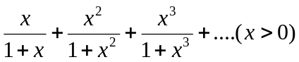.
b) Test for convergence of the series [ 5 ]
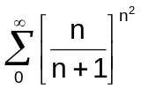.

2. a) Change the order of integration and evaluate [ 5 ]
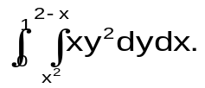
b) Find the volume of the solid generated by the revolution of the ellipse 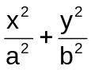=1 about the x-axis. [ 5 ]
3. a) Evaluate 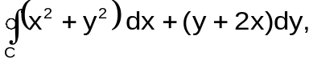where C is the boundary of the region in the first quadrant bounded by y²=x and x²=y. [ 5 ]

b) If is the position vector, prove that 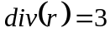 and 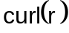=. [ 5 ]

4. a) If 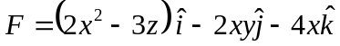, evaluate 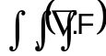dv where v is the closed region bounded by the plane x=0, y=0, z=0 and 2x+2y+z=4. [ 5 ]
b) Show that is irrotational. Find ϕ such that 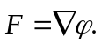 [ 5 ]
5. a) Verify Rolle’s theorem for the function f(x)=|X| in (-1,1). [ 5 ]

- If a<b prove that [ 5 ]
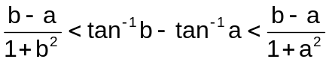,
by using Lagrange’s mean value theorem.

6. a) If u=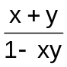, v=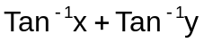 find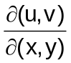. [ 5 ]
.
b) Test for maximum or minimum of the function u(x,y)=x²y²-5x²-5xy-5y². [ 5 ]

7. a) Show by the use of suitable elementary row / column operations that the matrix A can be reduced to the normal form 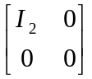, where [ 5 ]
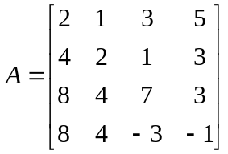.
- Show that the system of equations [ 5 ]
x+2y-5z=-7; 3x-y+2z=-5;2x+3y-z=3 are consistent and hence solve it.

8. a) State Cayley - Hamilton theorem and verify for A = 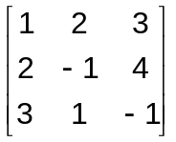. [ 5 ]
b) Diagnolize the matrix A=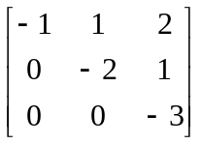. [ 5 ]
-- 00 -- 00 --

